Sysinternal tools

The SysInternals suite of tools is **simply a set of Windows applications that can be downloaded for free from their section of the Microsoft** Technet web site. They are all portable, which means that not only do you not have to install them, you can stick them on a flash drive and use them from any PC

The Sysinternals tools are divided into six categories: File and Disk Utilities, Networking Utilities, Processes Utilities, Security Utilities, System Information and Miscellaneous Utilities. There are many tools, but the widely known are **AutoRuns, Process Monitor, Process Explorer, TCPView and RootkitRevealer**.

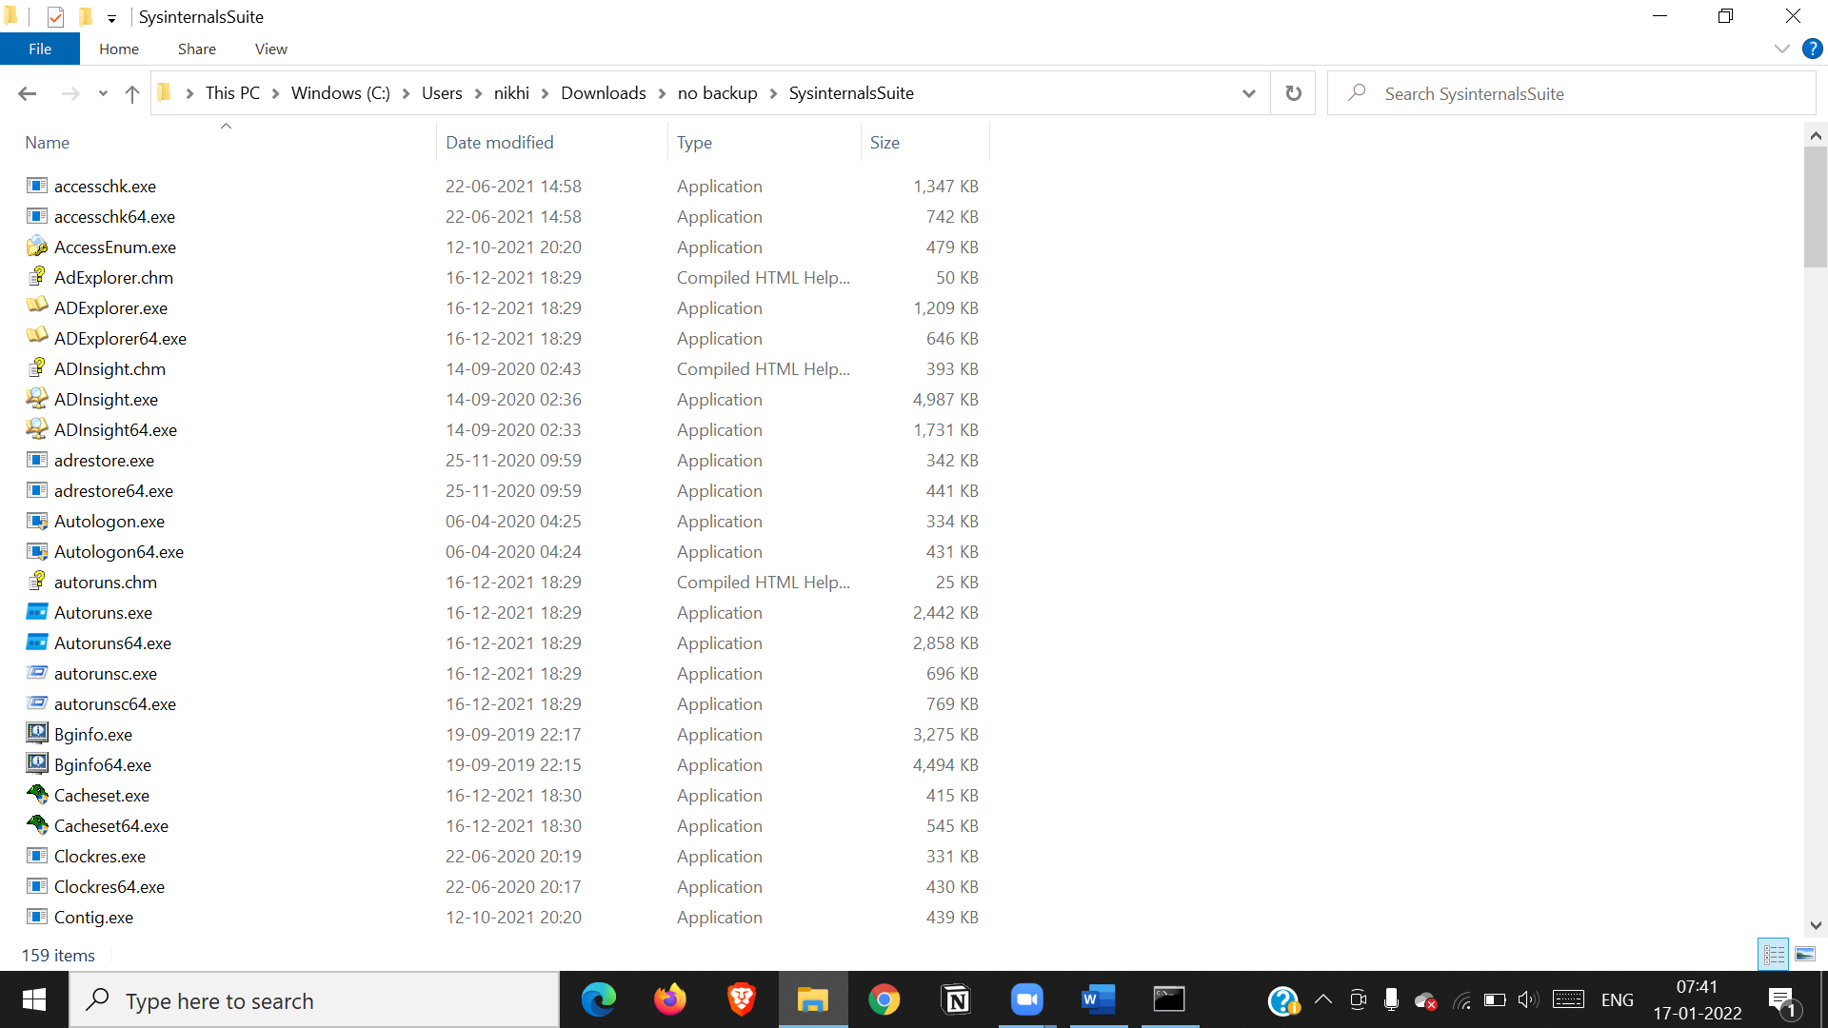

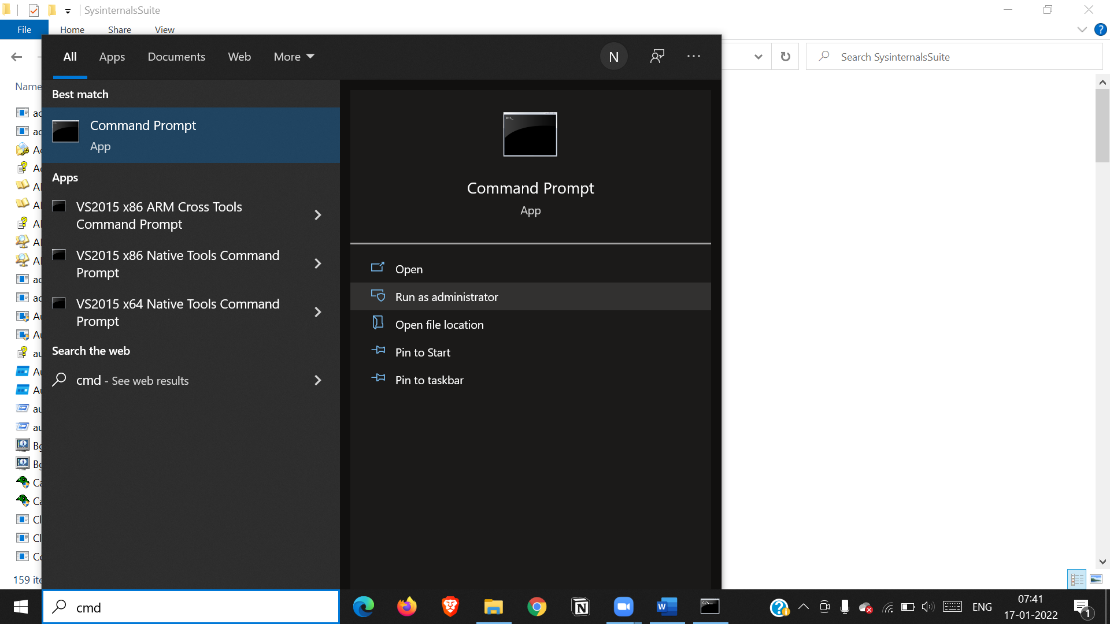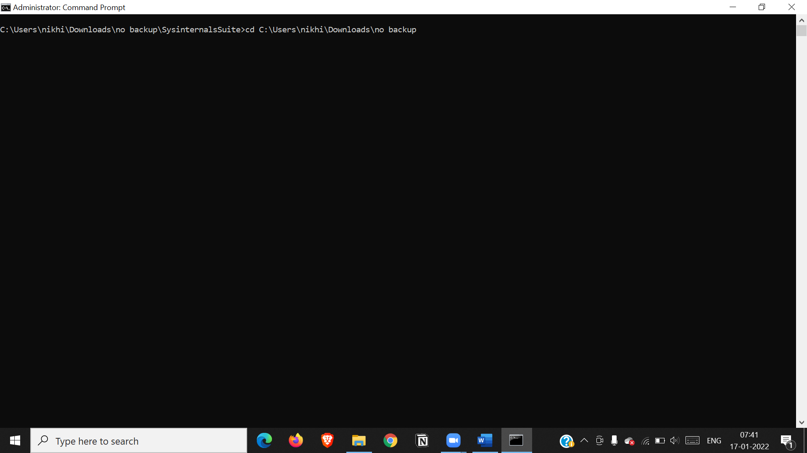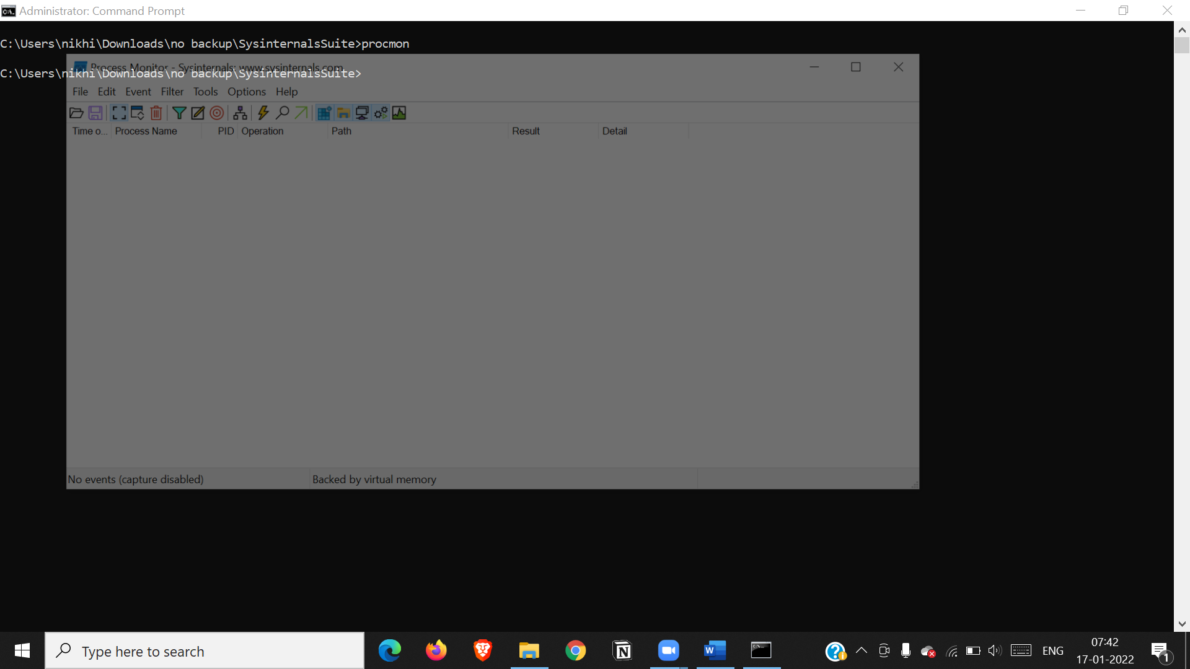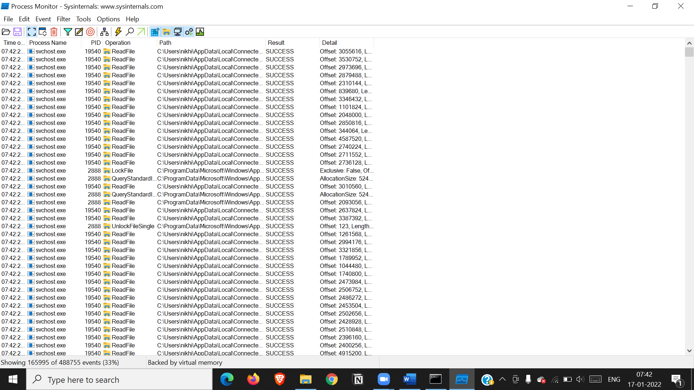

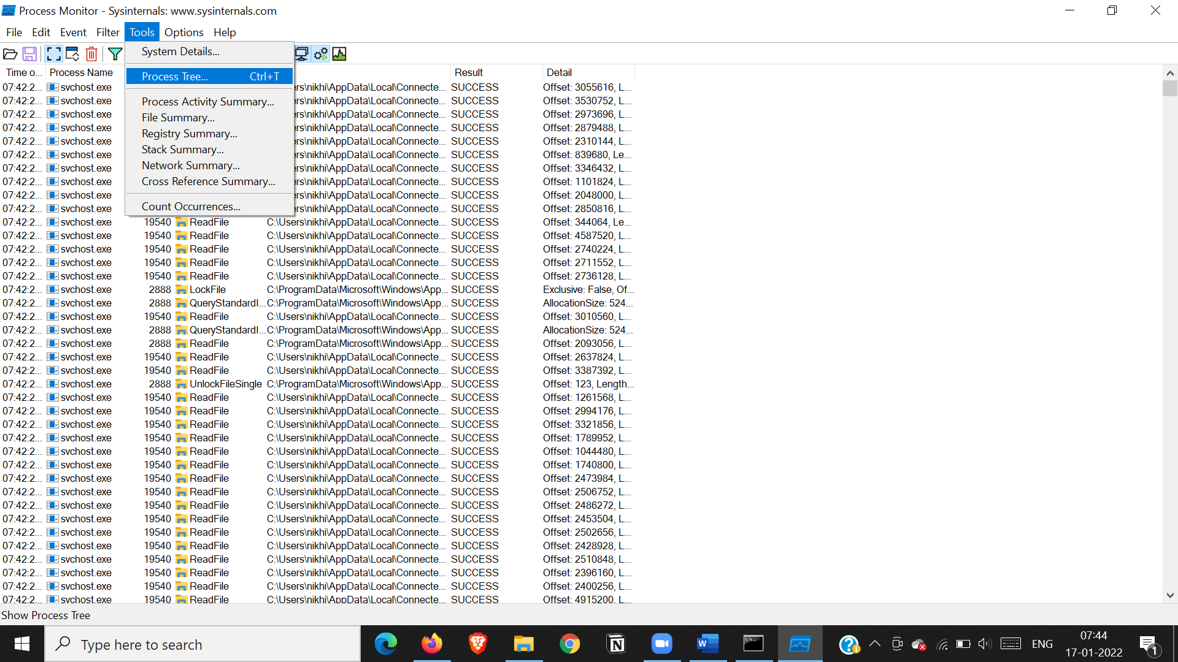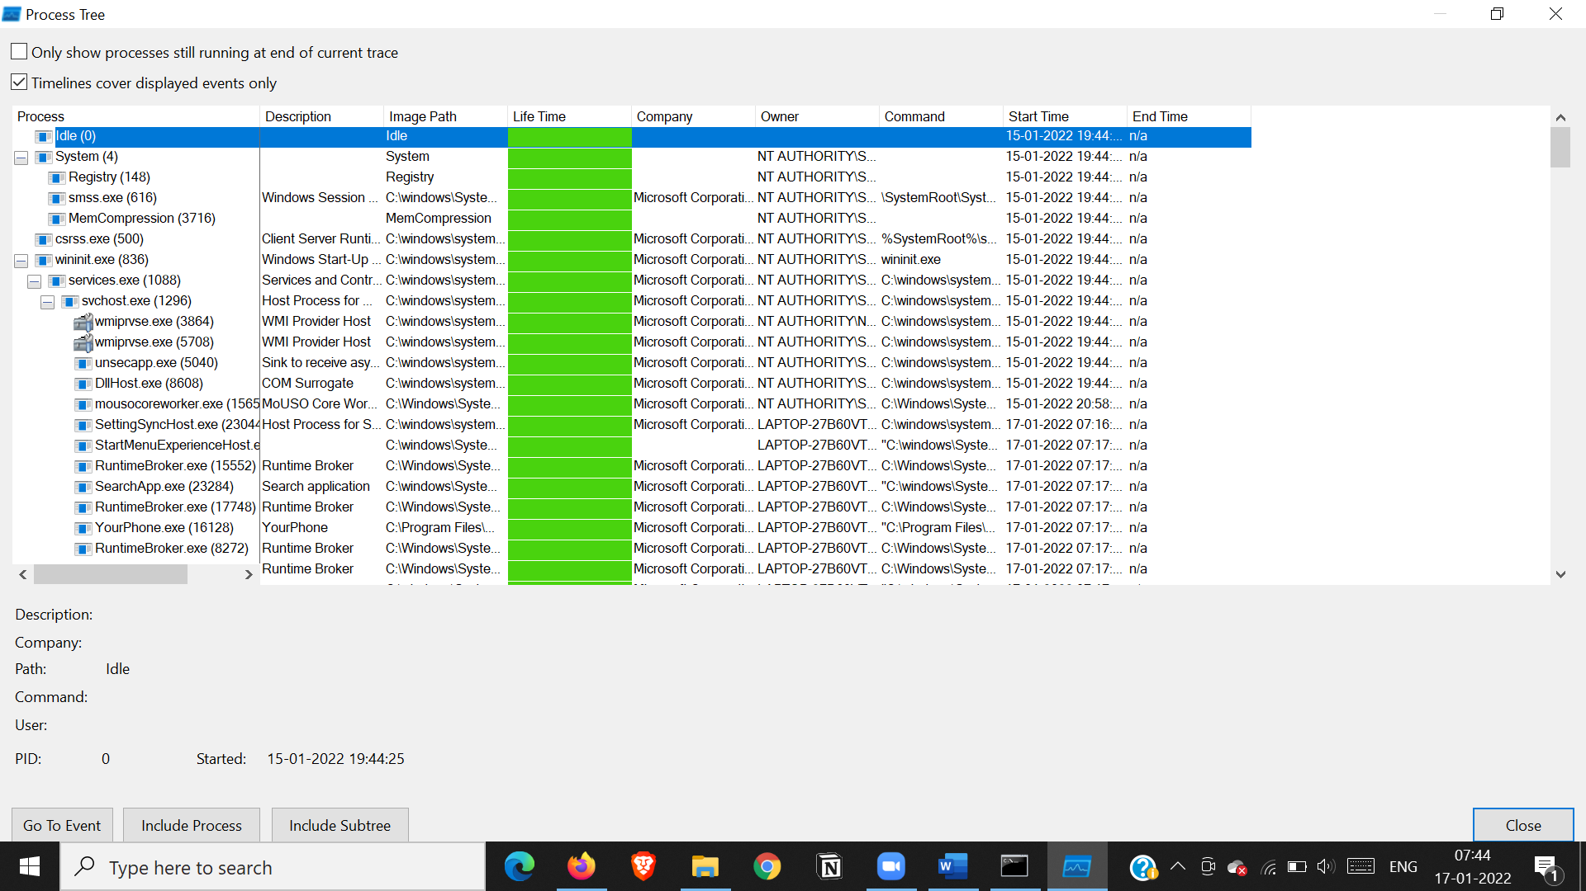

Tcp -udp packets

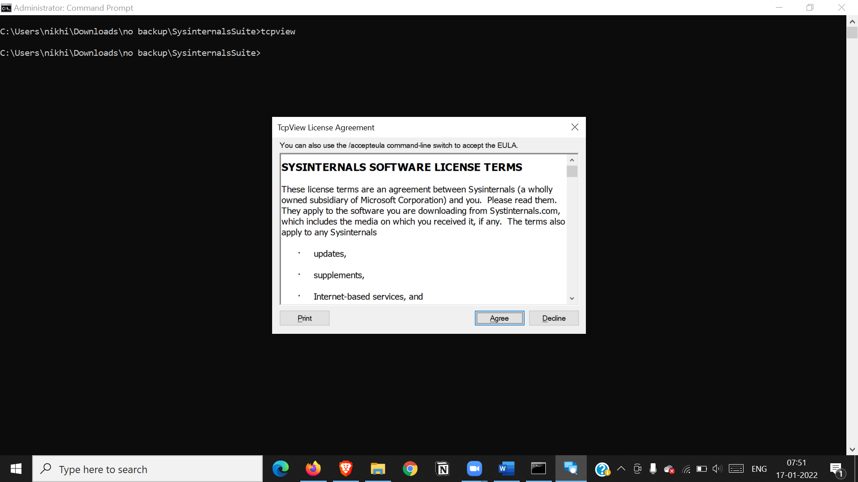

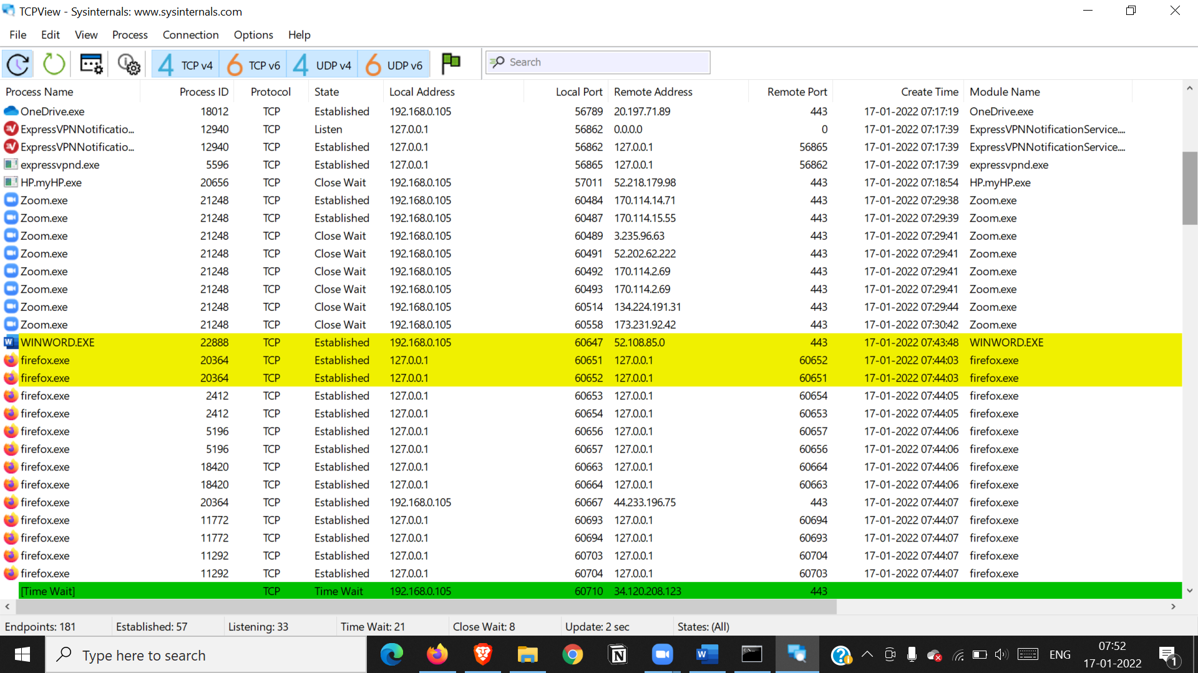

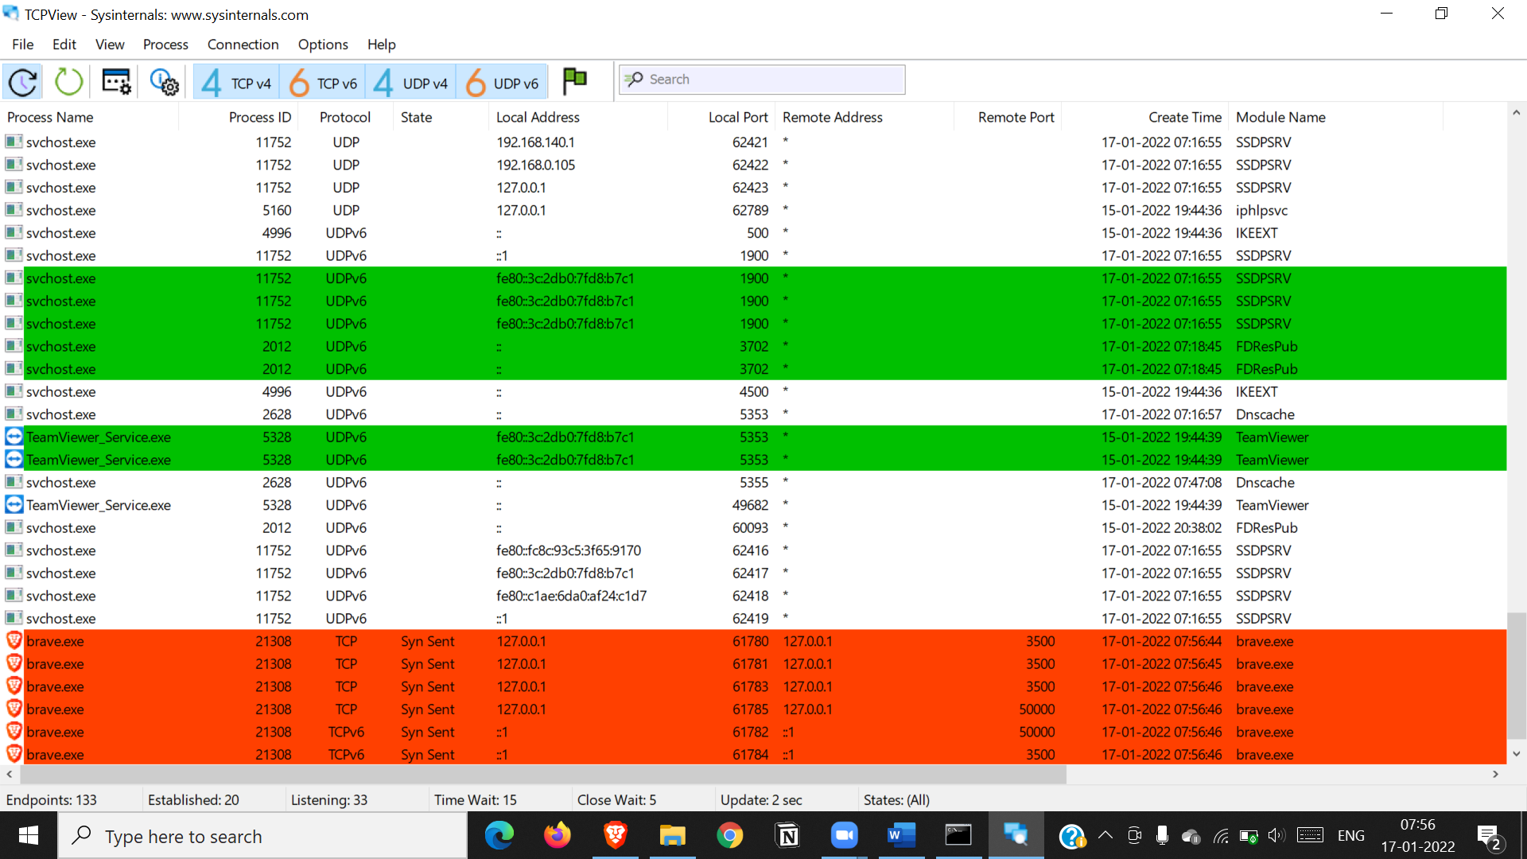

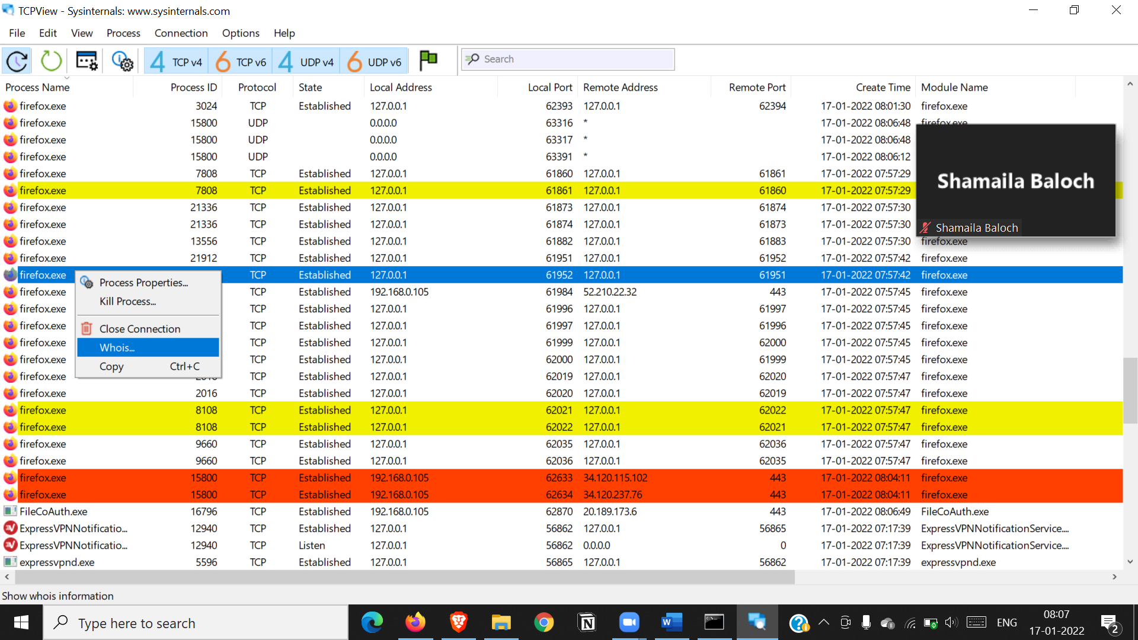

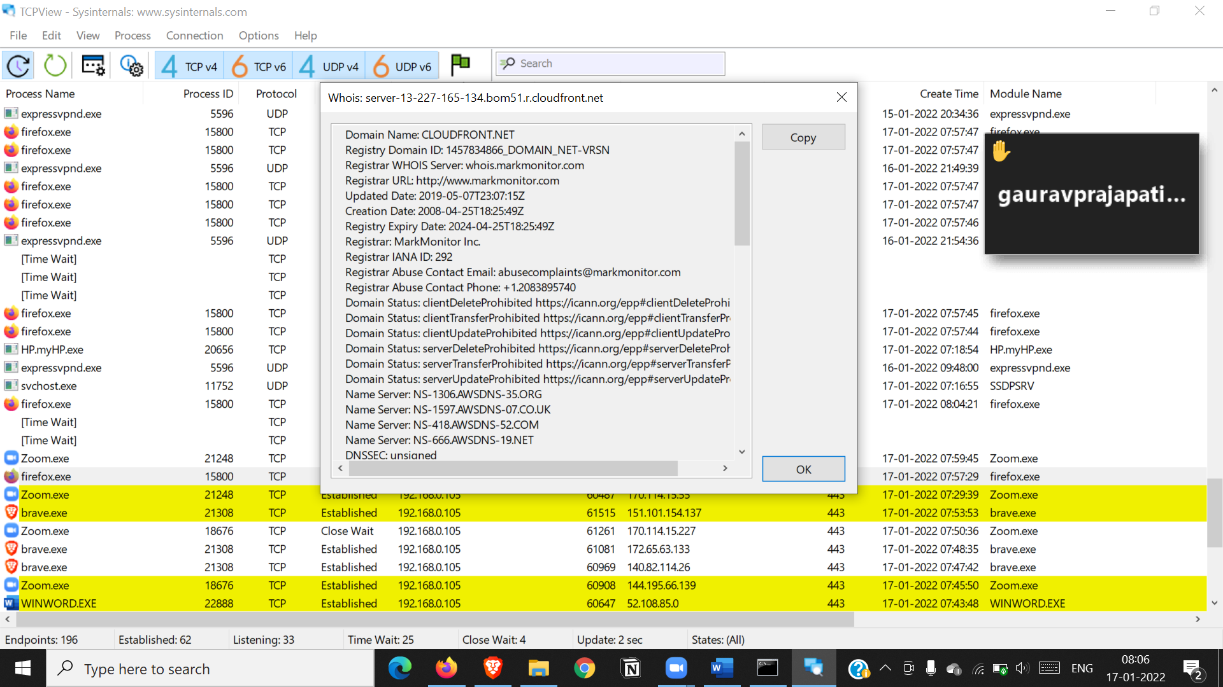

Diskmonitoring

